Week 10
write a program to create a digital clock using React.js
Create react app by using
npx create-react-app digital-clock
cd digital-clock
npm start

src/App.js
import React, { useState, useEffect } from "react";
import "./App.css";

function App() {
const [time, setTime] = useState(new Date().toLocaleTimeString());

// Update the time every second
useEffect(() => {
const timer = setInterval(() => {
setTime(new Date().toLocaleTimeString());
}, 1000);

// Cleanup timer when component unmounts
return () => clearInterval(timer);
}, []);

return (
<div className="clock-container">
<h1>Digital Clock</h1>
<div className="clock">
{time}
</div>
</div>
);
}

export default App;

src/App.css

body {
background-color: #282c34;
color: white;
font-family: "Arial", sans-serif;
display: flex;
justify-content: center;
align-items: center;
height: 100vh;
margin: 0;
}

.clock-container {
text-align: center;
}

h1 {
font-size: 2rem;
margin-bottom: 20px;
}

.clock {
font-size: 3rem;
background-color: #1c1f26;
padding: 20px 50px;
border-radius: 15px;
box-shadow: 0 0 20px #00bcd4;
}

Run by Using
npm start

Output
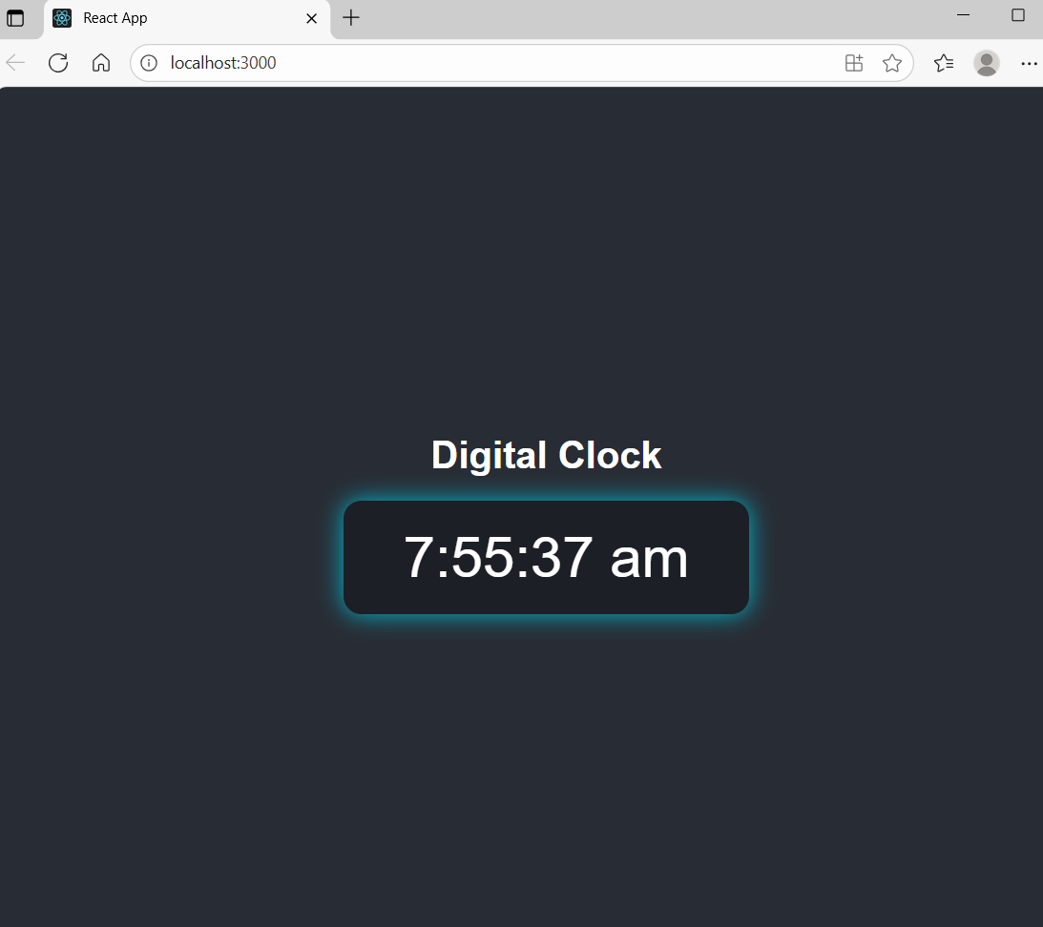

useState() | Manages the current time value as a state variable.

useEffect() | Runs once when the component mounts and starts a timer.

setInterval() | Updates the time every second (1000 ms).

clearInterval() | Cleans up the timer to avoid memory leaks.

toLocaleTimeString() | Converts the current time into a readable local format.

VIVA
What is useEffect used for in React?
Why do we use clearInterval inside useEffect?
What does useState do in this project?
How often does setInterval run?
What function gives the local time as a string?

